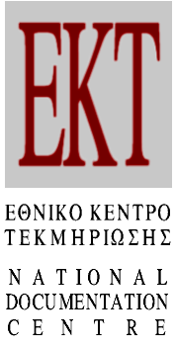 Athens, 14/03/2019
PRESS RELEASE
Greece is ranked 9th in the percentage of innovative enterprises in Europe for the three-year period 2014-2016
Eurostat has released the results of the Community Innovation Survey (CIS) for EU countries

Greece has moved up three places in the European ranking of innovative enterprises for the three-year period 2014-2016, reaching the 9th position among the EU-28 member states. The percentage of Greek innovative enterprises was 57.7%, an increase of 6.7 percentage points when compared with the three-year period 2012-2014, according to the CIS (Community Innovation Survey). The survey in Greece was carried out by the National Documentation Centre (EKT), in collaboration with the Hellenic Statistical Authority (ELSTAT).

The survey included approximately 11,000 Greek enterprises with 10 or more employees, in different sectors of economic activity. As seen from the results released by Eurostat, Greece and France share 9th place, with a percentage of innovative enterprises 57.7%. In the 1st place is Belgium with 68.1%, followed by Portugal with 66.9% and Finland with 64.8%. Ireland completes the top 10 countries with 57.3%. It should be pointed out that the percentage of innovative enterprises in Greece is higher by 7.1 percentage points compared to the average of the EU-28 member states (50.6%).

As shown by the results for the period 2014-2016, Greek innovative enterprises have implemented at least one of the following types of innovation: new or significantly improved products (product innovation), new or significantly improved processes (process innovation), new organisational methods (organisational innovation), new marketing methods (marketing innovation).

Particularly important is the position of Greece in product and/or process innovation, with a percentage of 47.1%, which ranks it 7th among EU-28 member states far above the European average (39.5%). Leading European countries in product and / or process innovation are Belgium with 62.1%, followed by Portugal with 58.5% and Finland with 58.2%. In 10th place is Estonia with 44.4% in product and/or process innovation.

Similarly, with an increase of 8.4 percentage points (46.7%) for the period 2014-2016 compared with the previous period 2012-2014 in organisational and/or marketing innovation, Greece placed 6th among the EU-28 member states with a percentage which is 10.1 percentage points higher than the European average (36.6%). The leading country in organisational and/or marketing innovation is Luxembourg with 52.8% and is followed by Austria with 51.8% and Ireland with 49.5%. Last in the top ten countries with organisational and/or marketing innovation is the UK with 40.5%.

Based on the results for the period 2014-2016, in the industry sector 59.5% of the enterprises innovate, while in the service sector this percentage is 56.5%.

From the industry sector, the branch of Manufacturing deserves further analysis since is the backbone of the industry sector with over 4,000 enterprises. The percentage of innovative enterprises in the Manufacturing sector was approximately 60%, with an increase of 4.4 percentage points (59.5% in three years period 2014 to 2016 and 55.1% in the three year period 2012 to 2014).

Within the Manufacturing branch, the sub-branches that stood out were the 'Manufacture of Chemicals' with 80.6% innovative enterprises, 'Manufacture of Beverages' 72.5%, 'Manufacture of basic pharmaceutical products and pharmaceutical preparations' 69.2% and 'Manufacture of rubber and plastic products' with the percentage of 69.1%.

Accordingly in the Service sector the highest percentage (62.7%) of innovative enterprises was recorded by the branch of 'Information and Communication', where, once again, the sub-branch of 'Computer programming, consultancy and related activities' was the leading category with 82.1% of innovative enterprises.

Note that statistics and indicators for Research, Development and Innovation in Greece are produced, published and transmitted regularly by EKT to Eurostat and OECD. Detailed statistical analysis and indicators can be accessed at: http://metrics.ekt.gr.

The CIS survey for 2014-2016 for Greece was funded by "Production of RIS3 Indicators for 2016-2013" project and was implemented by the EKT. The relevant statistical products were incorporated into the "Monitoring Mechanism of the Collection and Production of Indicators". The project is co-funded by Greece and the European Union (European Regional Development Fund) through the Operational Programme "Competitiveness, Entrepreneurship, and Innovation 2014-2020".

Web Links

"Main Indicators for Innovation in Greek enterprises 2014-2016" (in Greek)
http://metrics.ekt.gr/el/node/364

metricsΕΚΤ – Indicators & Statistics for Research, Development, Innovation
http://metrics.ekt.gr/en

Eurostat - Science, technology and innovation
https://ec.europa.eu/eurostat/web/science-technology-innovation/overview

Press Contact
National Documentation Centre
Margaritis Proedrou, tel.: +30 2107273966, e-mail: mproed@ekt.gr
http://www.ekt.gr

About the Greek National Documentation Centre
The National Documentation Centre (www.ekt.gr) operates as a national infrastructure at the National Hellenic Research Foundation. Its mission is:
- the collection, documentation, dissemination and long-term preservation of authoritative digital content and data produced by the Greek scientific, research and cultural communities,
- the measurement of Research, Development and Innovation (RDI) output and results and their comparison on European and international levels,
- the strengthening of the broader national goal of exploiting research results and strengthening innovation
- the uninterrupted operation of the national computer infrastructure, which ensures friendly access to reusable reliable information, the collection and distribution of data and the production of indicators for RDI in Greece, as well as a range of services for research, academic, educational and business communities.

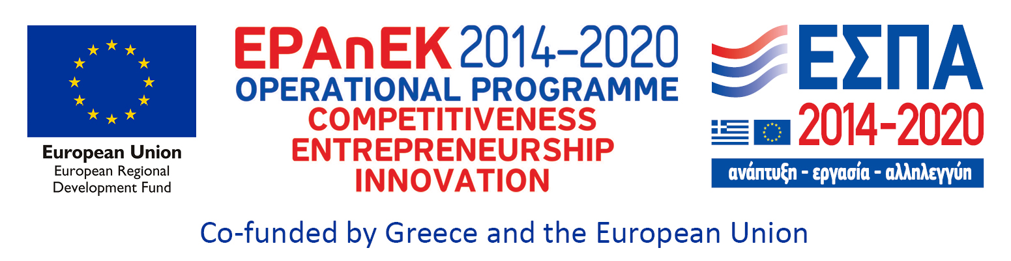

Selected charts showing innovation for Greek enterprises during the three-year period 2014-2016, according to CIS (Community Innovation Survey) results

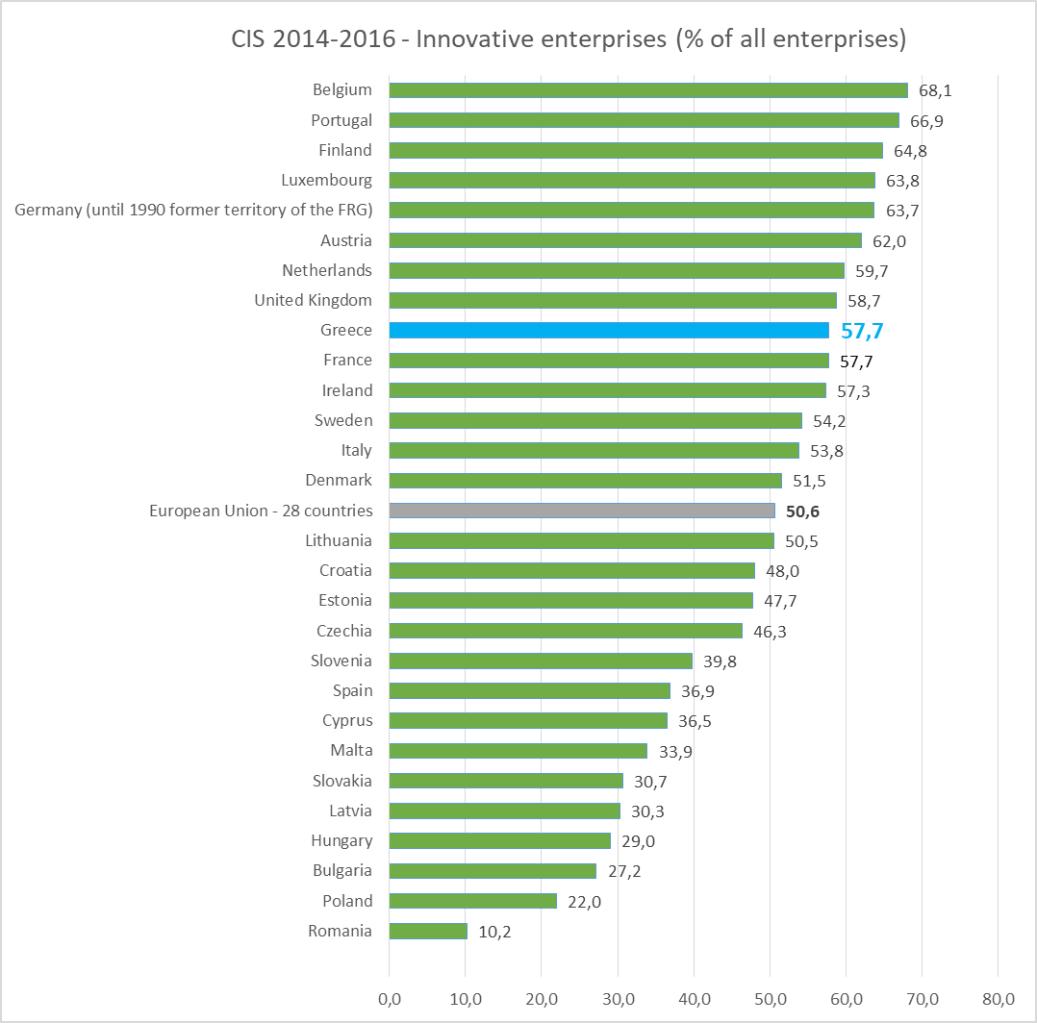
Source: Eurostat, Editing: National Documentation Centre (EKT)

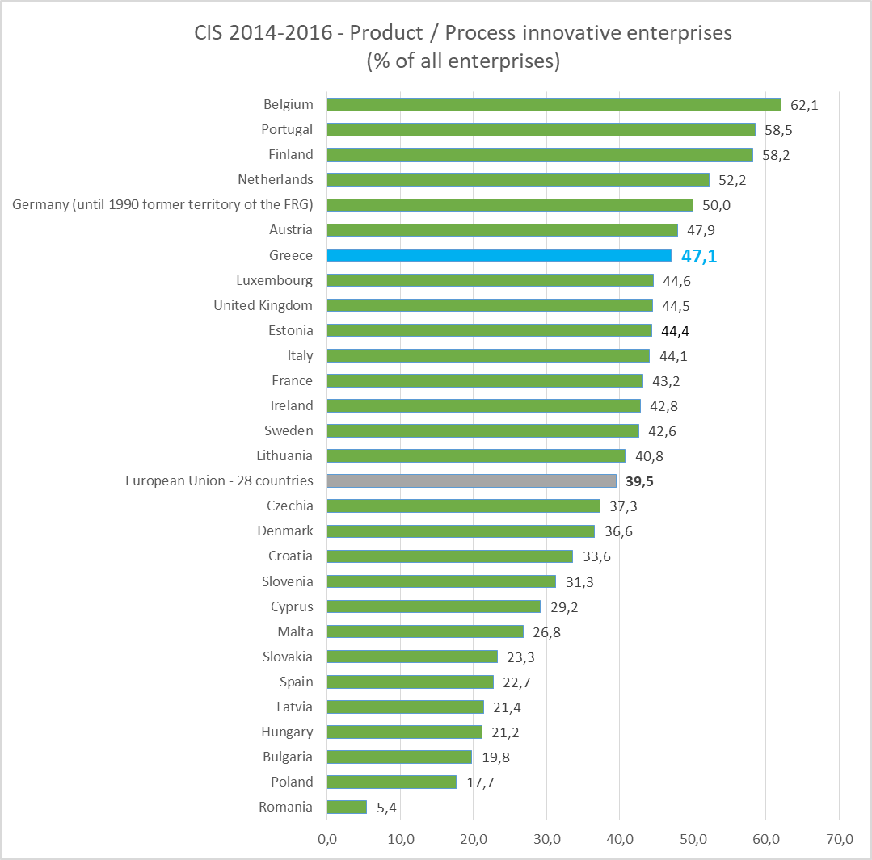
Source: Eurostat, Editing: National Documentation Centre (EKT)

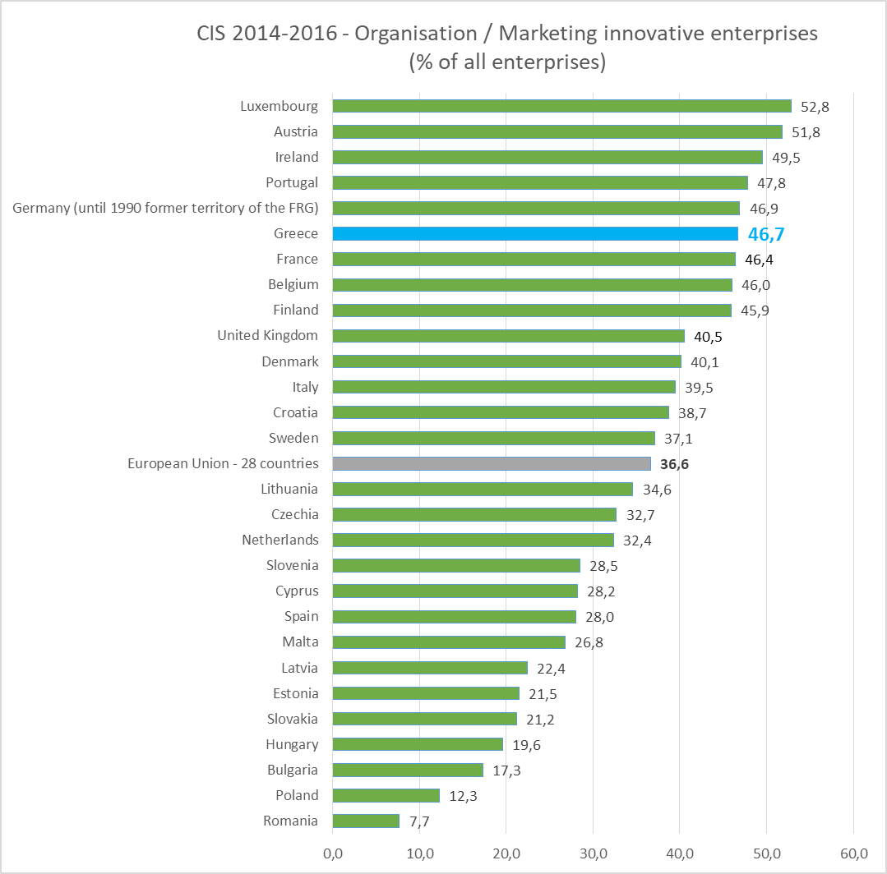
Source: Eurostat, Editing: National Documentation Centre (EKT)

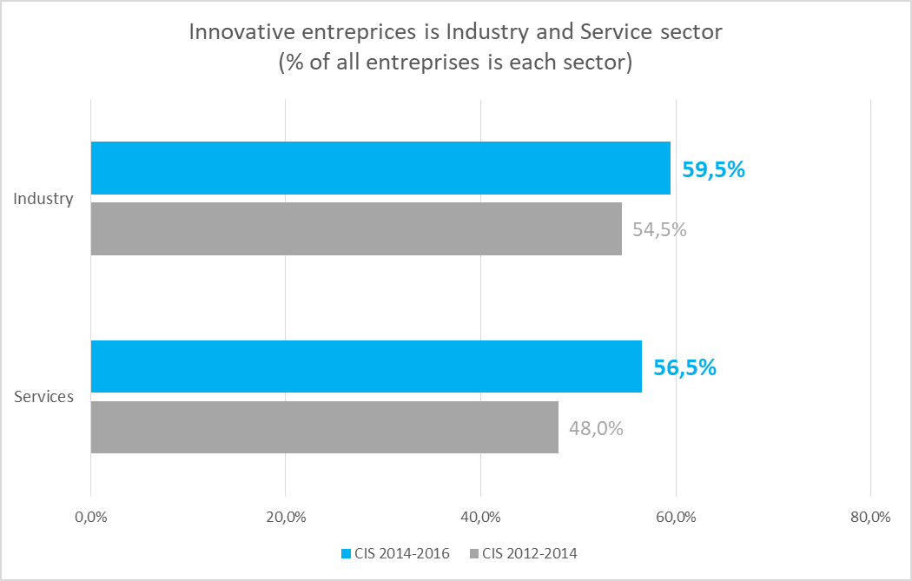Source: National Documentation Centre (ΕΚΤ), http://metrics.ekt.gr

