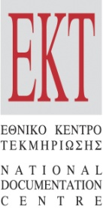 | 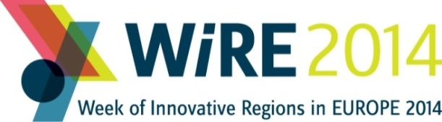  www.wire2014.eu

PRESS RELEASE | Athens, April 30th, 2014

WIRE 2014 International Conference - Rebooting Regional Policy for Innovation and Growth, Athens, June 12th and 13th

The "Week of Innovative Regions in Europe 2014" (WIRE V) will take place this year in Athens under the auspices of the Greek EU Presidency. The Conference (www.wire2014.eu) is organised by the National Documentation Centre of Greece (EKT) and the European Commission, in collaboration with the General Secretariat for Research & Technology. The conference will take place in Aegli Zappeiou on June 12th and 13th, in the presence of the Commissioner of the European Commission for Research, Innovation and Science, Máire Geoghegan-Quinn. Registration for the conference is now open.

Since 2010, WIRE has been established as the most significant European forum dedicated to regional strategies, innovation and development. The launch of "Horizon 2020" programme for Research and Innovation, and the new regulation for the European Structural and Investment Funds (ESIF) announced within the first semester of 2014, provide an excellent timing for this year’s WIRE. At this critical point, the Conference will build on the public dialogue for the discovery of effective procedures, instruments and best practices leading to the successful implementation of Smart Specialisation Strategies for European Regions.

Towards a new architecture for regional innovation strategy, WIRE 2014 will cover the following thematic areas:
i. European funding for Regional Development in 2014-2020:
Regional intelligence in RIS3; Investing in smart priorities under Horizon 2020 and ESIF; optimal design and implementation of Smart Specialisation Strategies; research and innovation to counterbalance the impact of the financial recession; adaptation of policies to territorial specificities; the role of knowledge-based economy in the Territorial cooperation; initiatives on regional and urban development;
ii. Business driving Regional innovation
Business contribution to the regional ecosystem for growth and job creation; engaging companies in RIS3; access to finance for SMEs; digital innovation and regional growth; cluster policies; innovative business transforming the regional environment
iii. Scientific Excellence, Open Data and Knowledge re-use for regional growth: Open public data for regional innovation, S&T metrics for designing and evaluating efficient regional policies; scientific excellence as competitive advantage of regions; synergies between research institutions, local government and knowledge intensive companies.

EU high level officials, representatives of the Organization for Economic Cooperation, the World Bank, the European Structural and Investment Funds and managers from regional associations, local authorities, development agencies, organizations, research institutions, business associations and clusters have already confirmed participation in WIRE 2014.

With an aim to narrow the innovation divide among European regions and to align national and European strategies for Smart Specialisation, WIRE 2014 will present best practices, new policy instruments for the programming period 2014-2020 and scientific recommendations for knowledge reuse. Acknowledging that scientific excellence and knowledge reuse are essential building blocks for regional innovation, WIRE 2014 will point to the urgent need for effective evaluation policies and systematic mapping of research activity.

English is the official language of the Conference. There is no registration fee, however, participants are required to register online at http://www.wire2014.eu/registration-form. For more information about WIRE2014 thematic areas, speakers, agenda, practical details about arrival in Athens and accommodation, conference news and features, visit WIRE2014 official website (www.wire2014.eu) or find us on social media (www.wire2014.eu/social-media, #WIRE2014eu).

Contact Info: wire2014@ekt.gr

Press contact: press-wire2014@ekt.gr (tel: +30210 7273966)

